Process Document of Part Creation and EBOM Process
Submitted to:
Kirloskar Oil Engine Limited(KOEL)
Date: 24 April 2020

Revision 1.0

Submitted By:
Kloudq Technologies Limited
Plot No.1,Yena,Adwaitnagar,
Paud Phate,Erandawana,
Pune-411038,Maharashtra,INDIA|

Table of Contents
1. Procedure for Part Creation 3
2. Types of Parts 4
3. Procedure for creation of Proto Part 4
4. Significance of 5 Segments 5
5. Various Tabs 6
6. Process for creation of Document 8
7. Adding BOM Structure 10
8. Promotion Request 12

Procedure for Part Creation
- On Home Page, select browse option at left highlighted navigator bar.
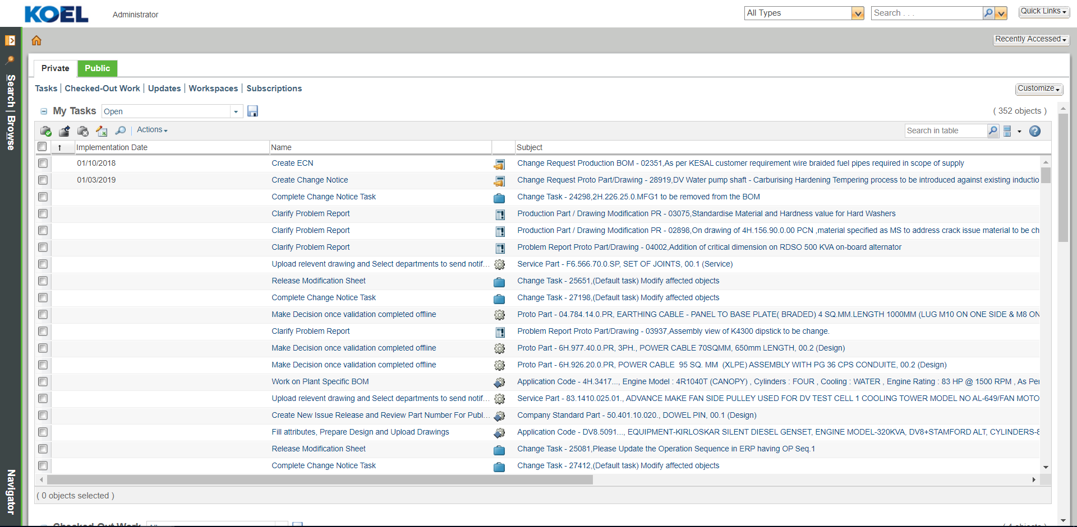
- Go to BrowseERP Data Lib
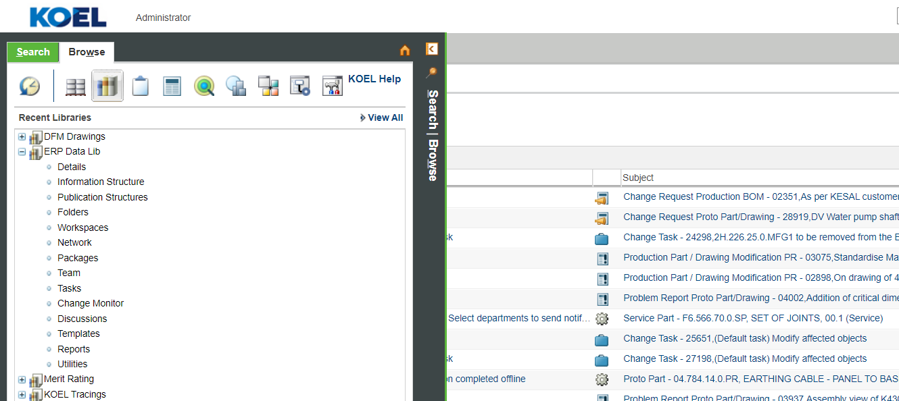
- Click on KOEL New Part.
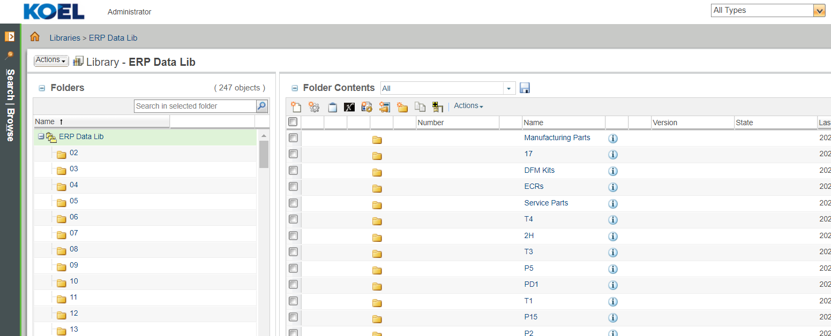

- New Window appears.
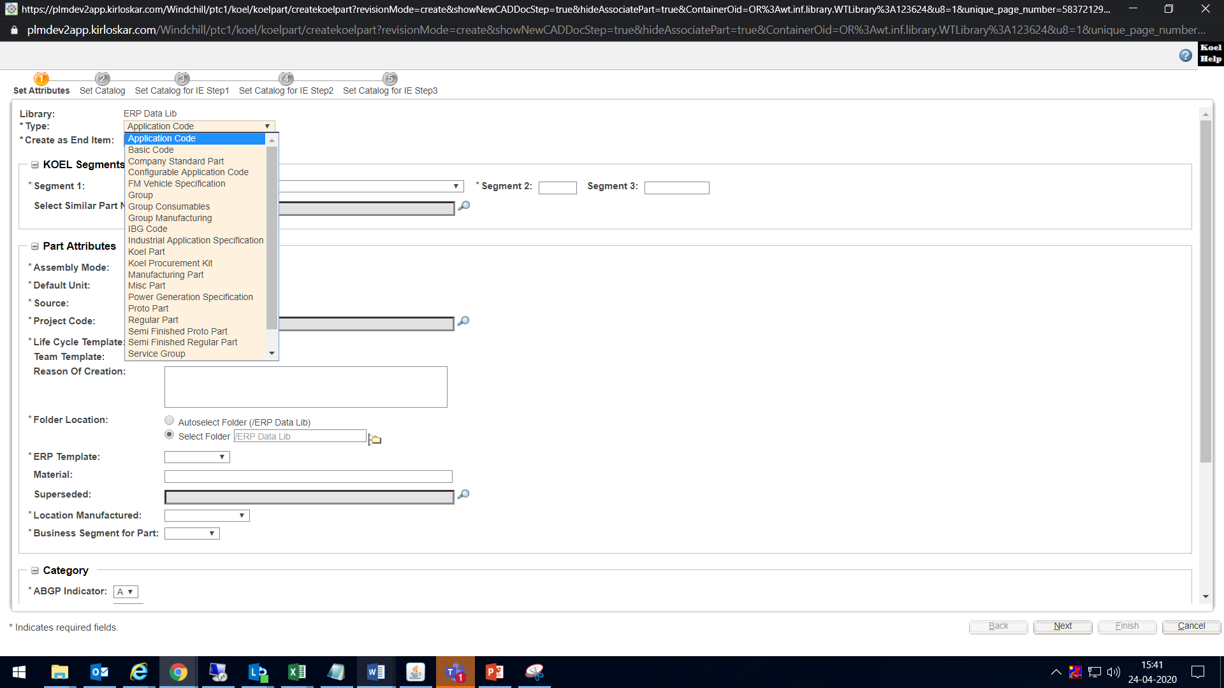

Types of Parts

- Application code
- Basic Code
- Configurable Application code
- Company Standard Part
- Group
- Industrial Application Specification
- Manufacturing Part
- Power Generation Specification
- Proto Part
- Regular Part
- Semi finished Proto Part
- Semi finished Regular Part

Procedure for creation of Proto Part
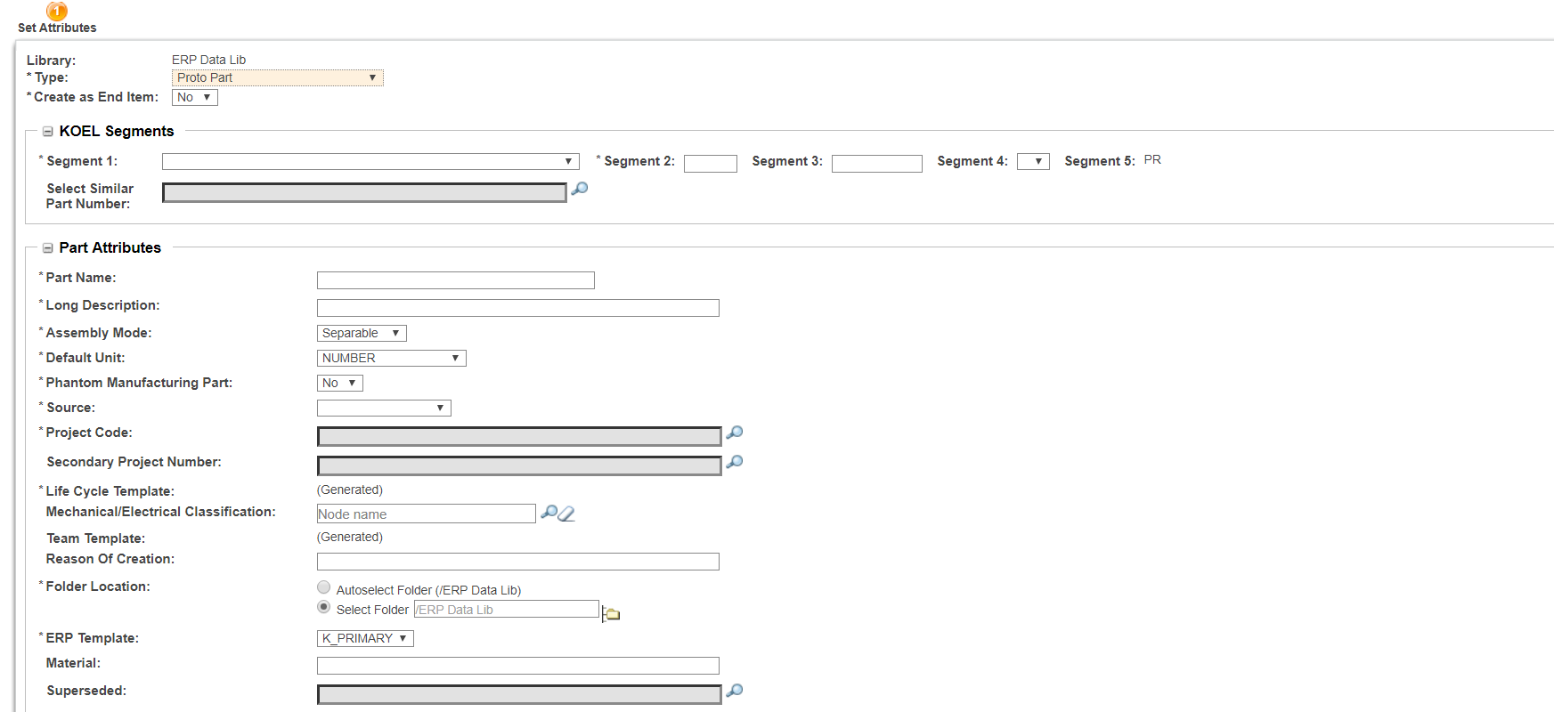
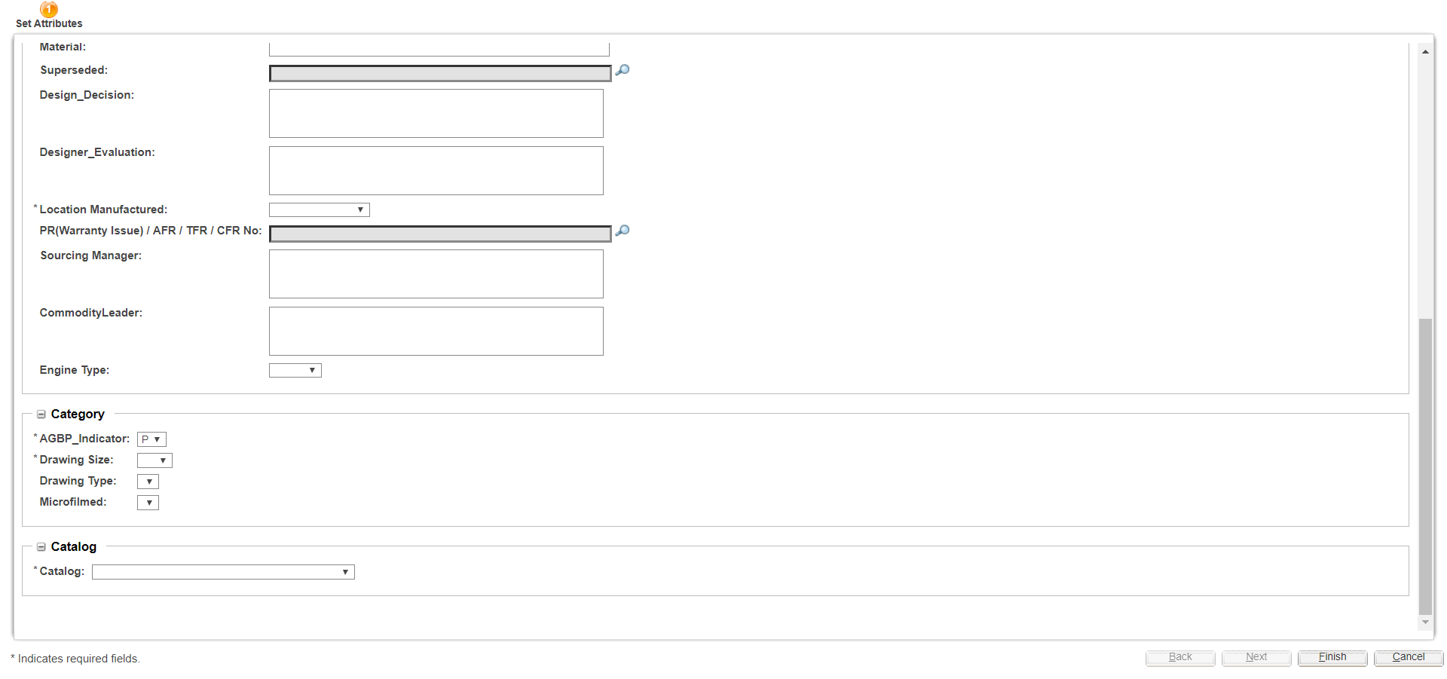

- After Filling all mandatory attribute, Click on finish button.
- (Below is detail tab of created part)

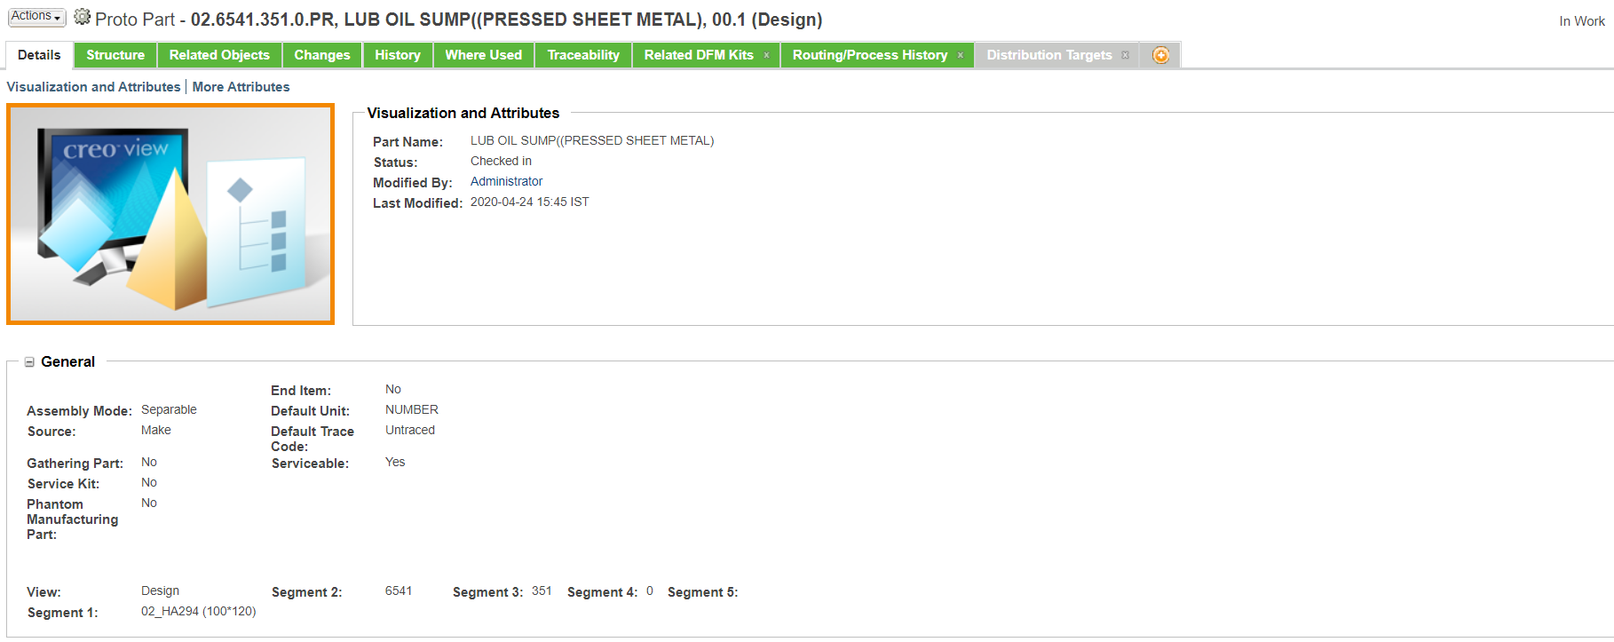

Significance of 5 Segments

- 02 Engine type
- 6541 Group or Code
- 351 Group Variant or Code Variant or Serial No.
- 0/1 Status (Finished/Semi Finished)
- PR/00 Part Type (Proto Part/ Regular Part)

Various Tabs
- Details : It contains all the attributes filled while creating the part.
- Structure : User need to add the BOM structure under the assembly.
- Related Objects : It contains all the attributes various associated documents (Described By Documents, Reference Documents, CAD/Dynamic Documents).
- Changes : It contains the history related to Change management process.
- History: It contains the entire progress of part. It is captured by version & iteration.
- Where Used : It contains the details related to where is this part been used.
- Traceability : It contains the Upstream & Downstream Traceability.
- Related DFM Kit : It contains the DFM kit which holds this part.
- Routing/Process History : All the tasks are available in this tab.
- Distribution Targets : It contains various organizations to which the BOM shoiuld be released.

- In Routing/Process History, task available is “Select Designer Evaluation”

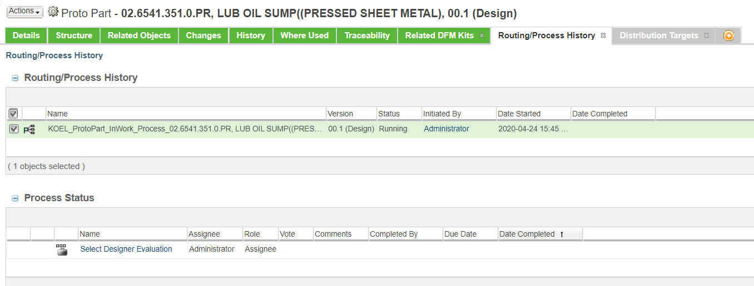

- Select this task, on task completion page there are 3 routing options such as Alpha0, Alpha1, Beta.(It refers to the stage of development of part)
- Before completion of task select these option by clicking in the respective checkbox.

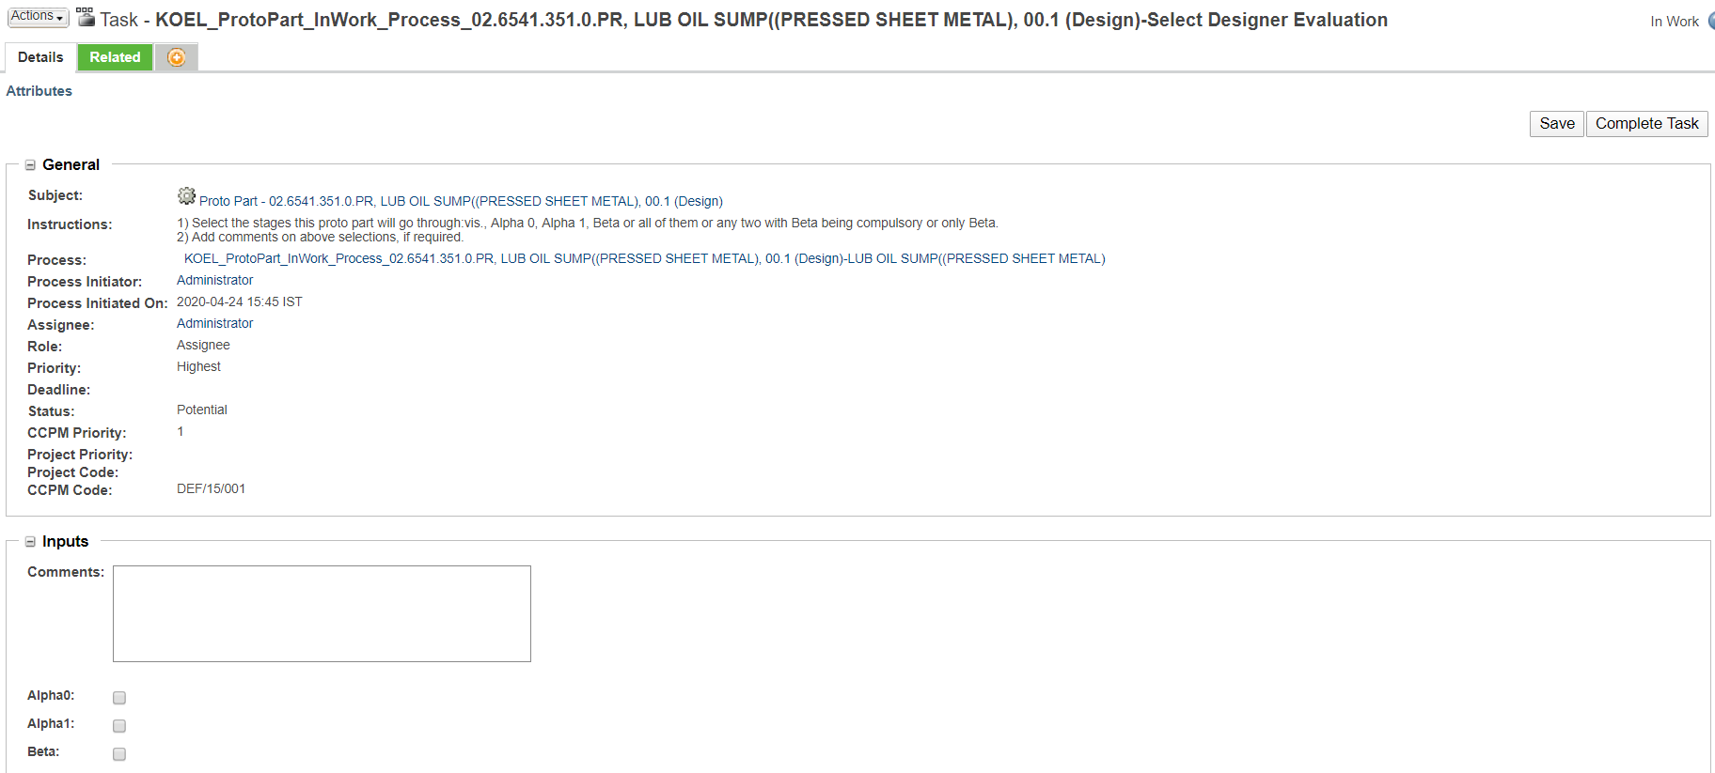
- The next task available in Routing/Process History is “Fill attributes, Prepare Design and Upload Drawings”
- Select the task for completion.
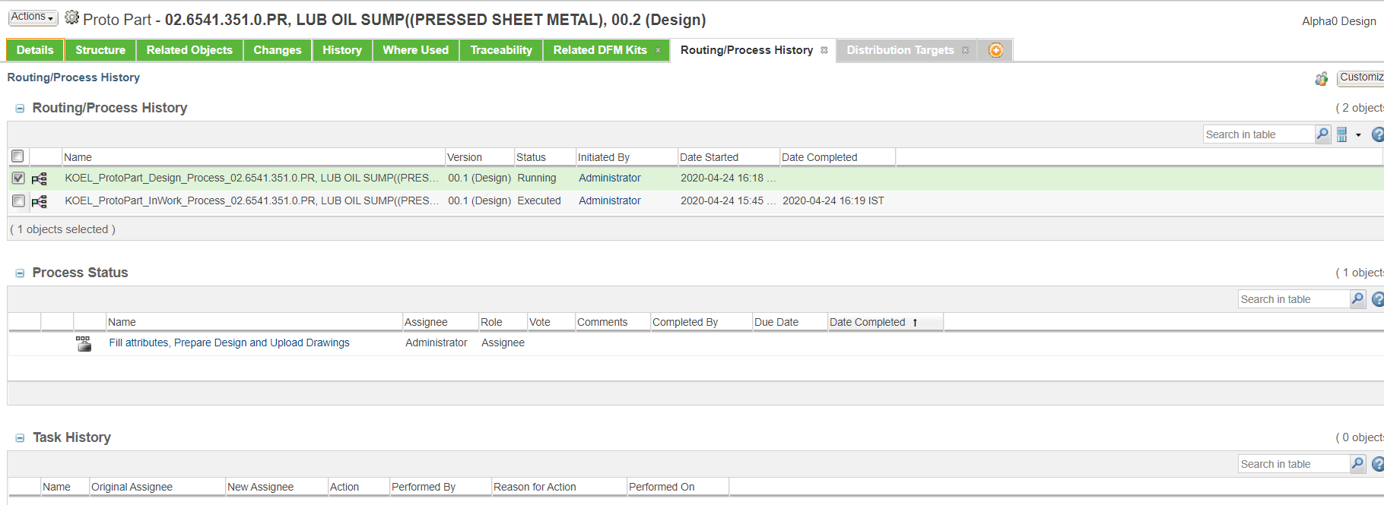

- On task completion page, there are various routing options available to be selected as per requirement.
- If part is to be sent for DFM and/or simulation, click on checkbox. (Process of DFM & Simulation is carried separately)
(For DFM Process, please follow respective document)

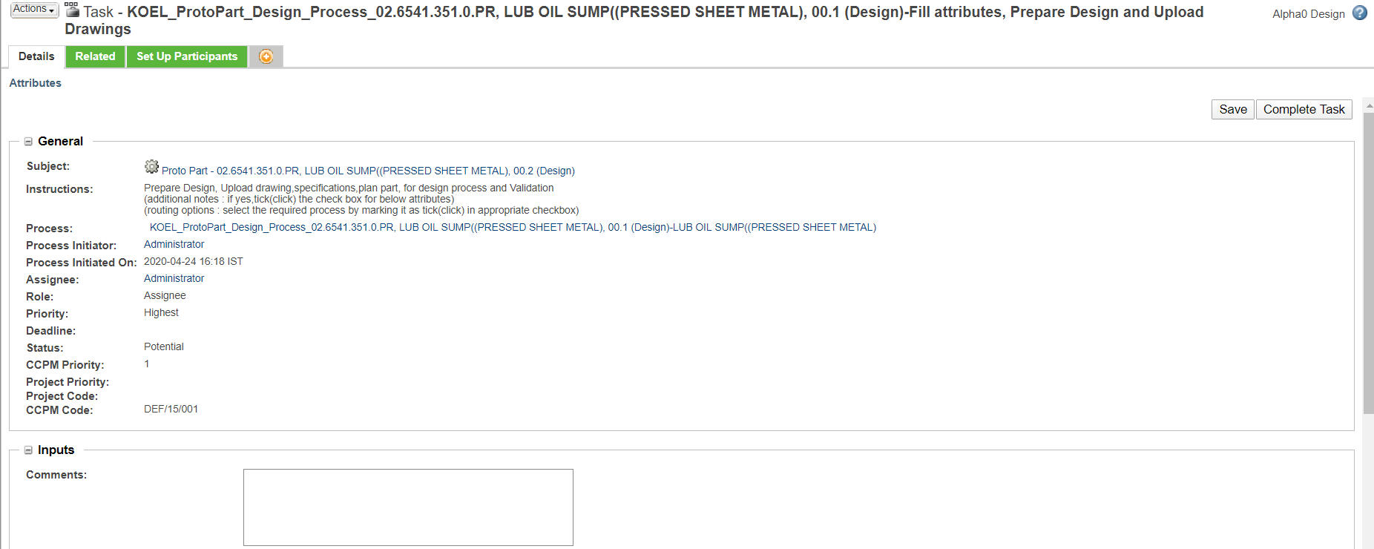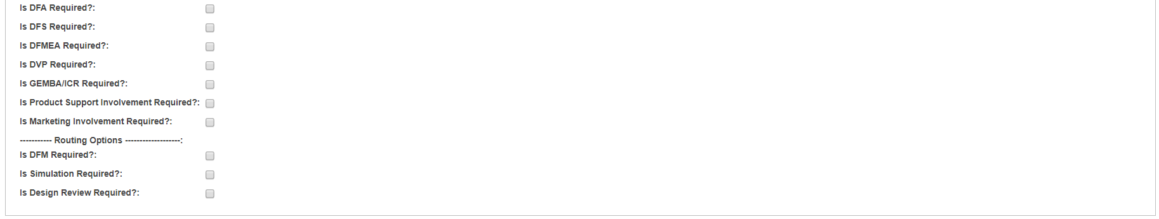

Set Up Participants contains the role/members to be assigned for the process approval.

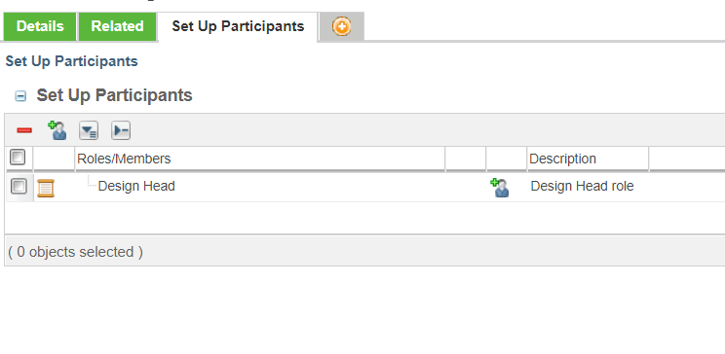

- Next task is “Upload final Drawing”

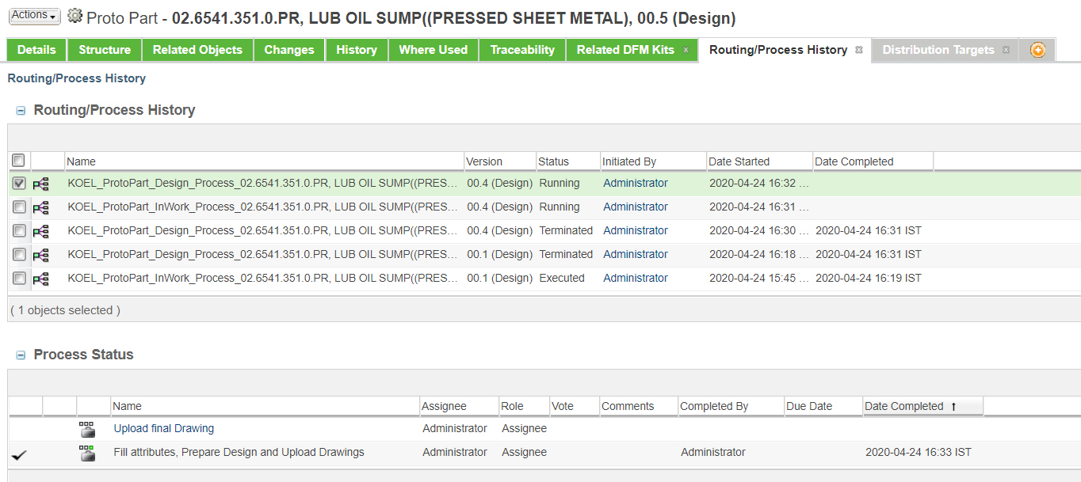

- For completing this task, drawing should be created & uploaded in related objects tab under described by documents section.

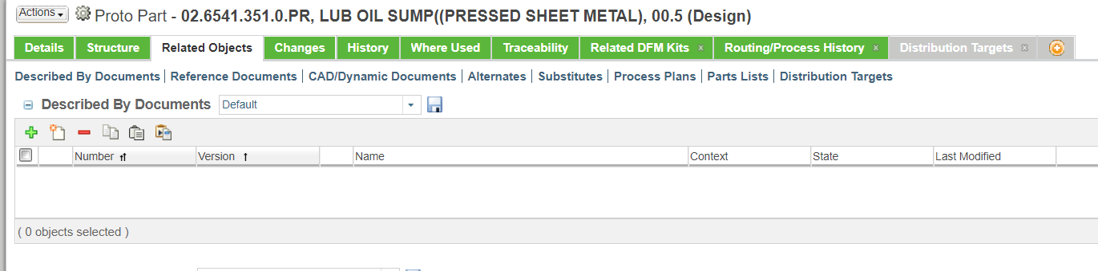

Process for creation of Document
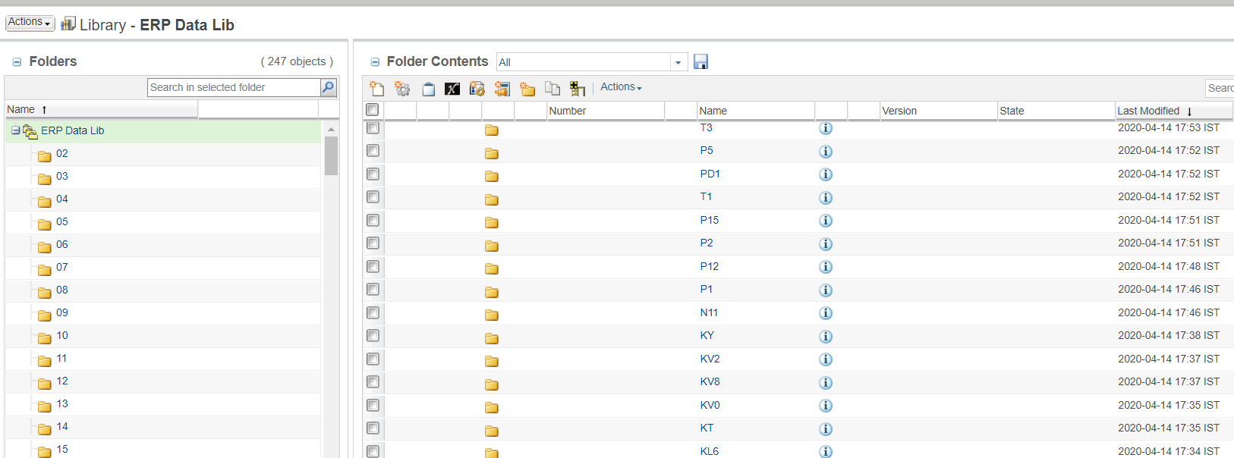

- A New Window Appears, there are several type of documents which can be created.

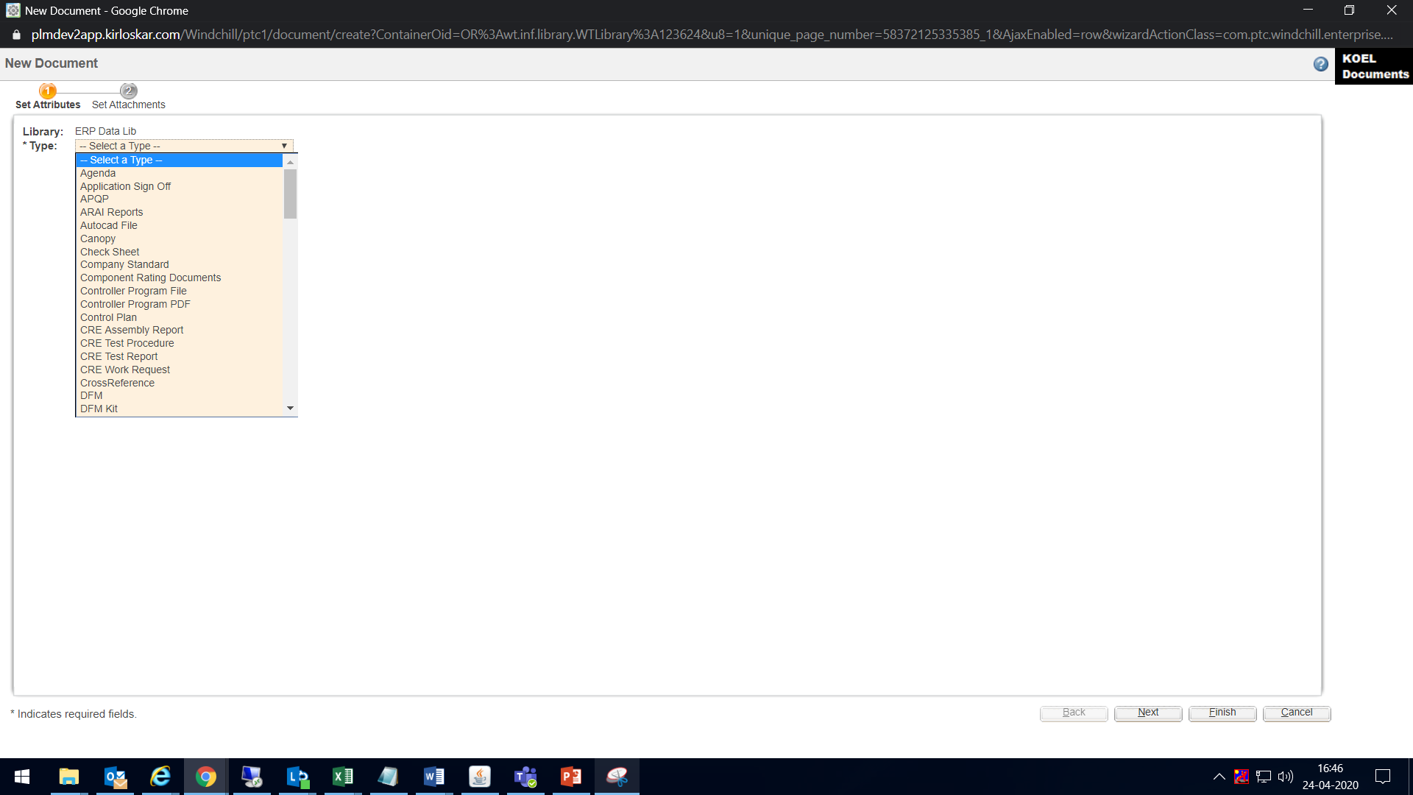

- Eg. KOEL Tracing :

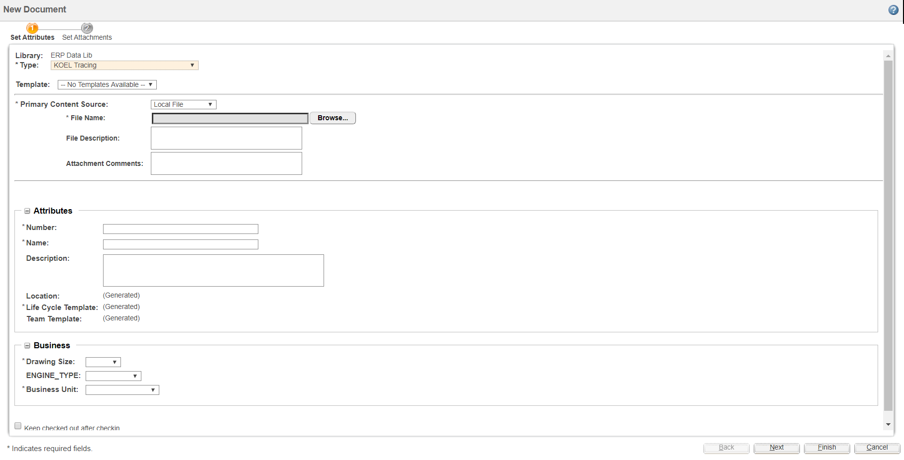

- After filling all the mandatory attributes, click on finish.

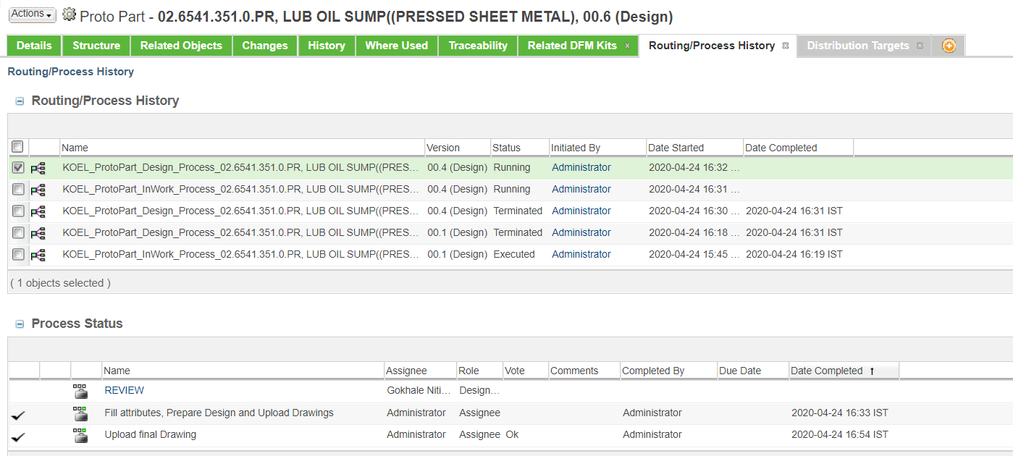

- This task is available with Design Head for review. There is routing option for “Release to ME ATPP” & “Rework”
- If Reworked, the task is sent for design engineer for making required changes.

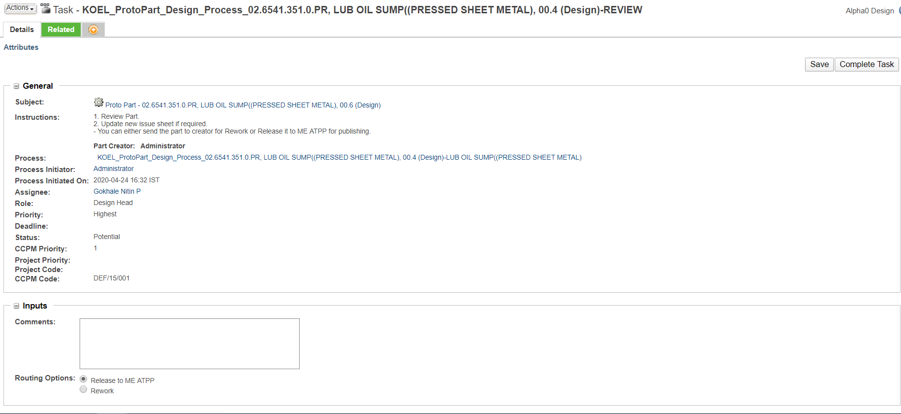

- If Release to ME ATPP, the part undergoes publishing if it is standalone (it’s state changes to “Released to ERP”) or else it has BOM Structure (it’s state changes to “Release to ME”)

Adding BOM Structure
- Go to Structure tab Uses
- In Number tab, enter part number a new window appears.

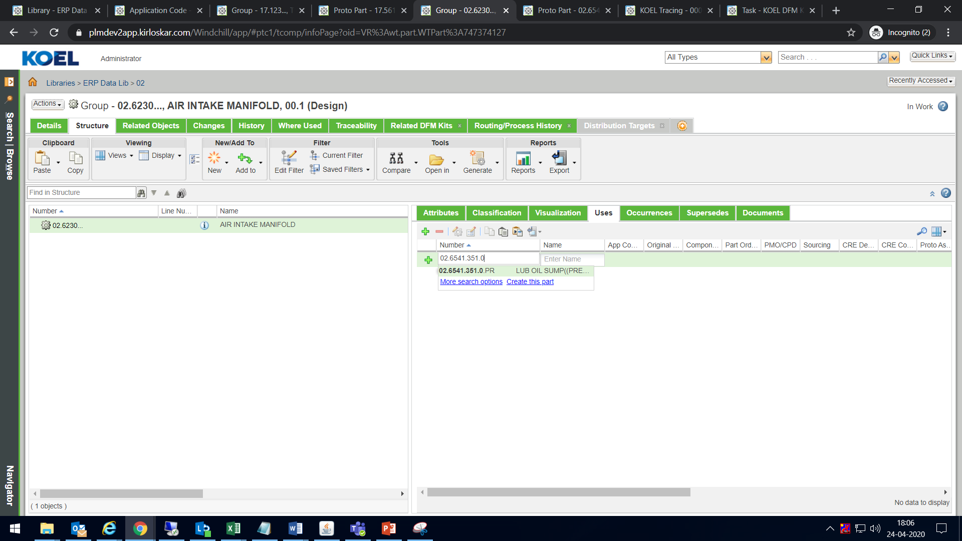

- Provide line number and below required attributes.

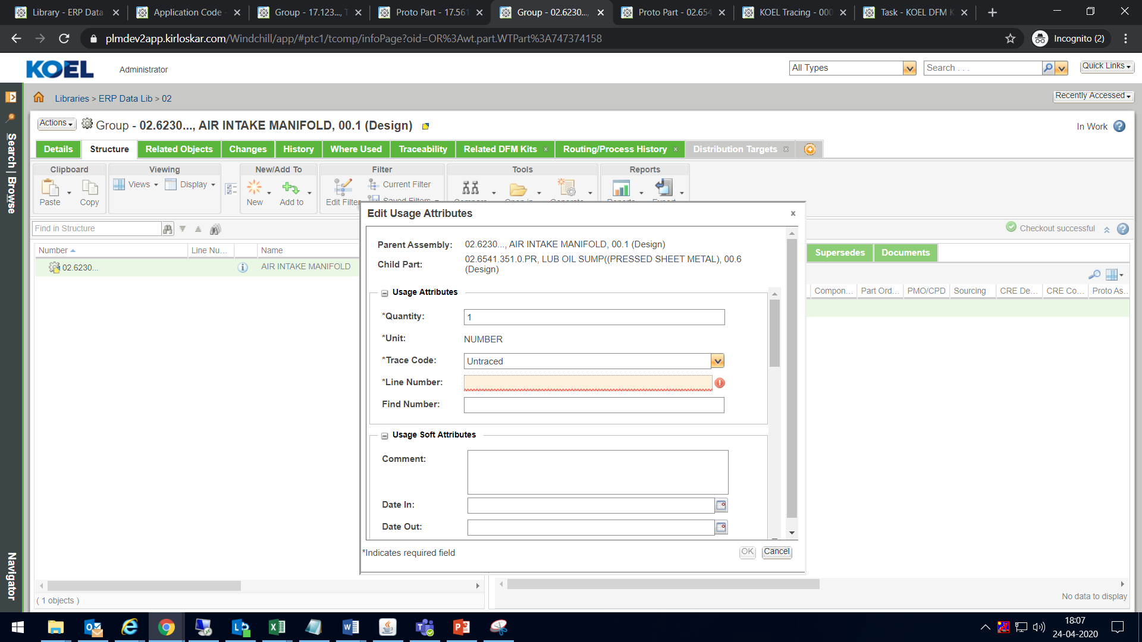

- While adding BOM Structure the assembly gets checked out (It is identified by a yellow box).

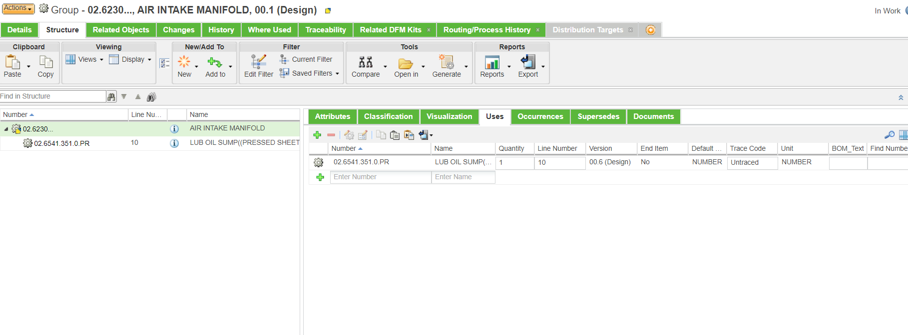

- After adding BOM Structure, this checked out assembly need to be checked in.

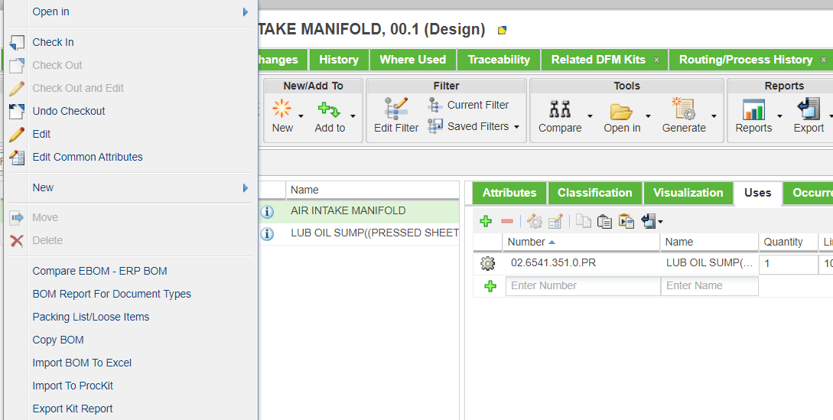

  - Promotion Request

- For Group, if ERP Template is "K_GROUP" raise Promotion Request (Created by Design)
- Company standard Part
- Group Manufacturing ( For Splitting of groups )
- Manufacturing Part ( Created by ME)
- Regular Part ( Created by Design)
- Semi finished Regular Part (Created by ME)

Steps to raise Promotion Request

- To release BOM having ERP Template as "K_GROUP". Actions

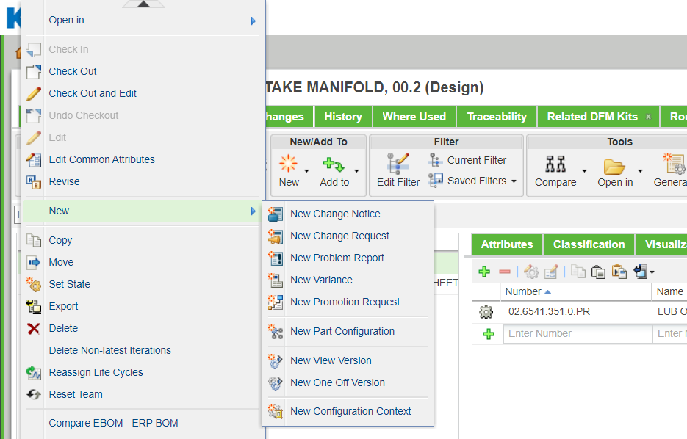
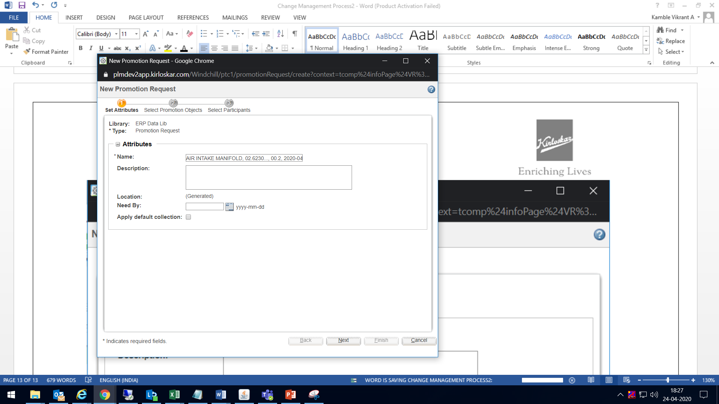

- Select the checkbox and Set the Target Promotion State : Design Approval & Obsolete

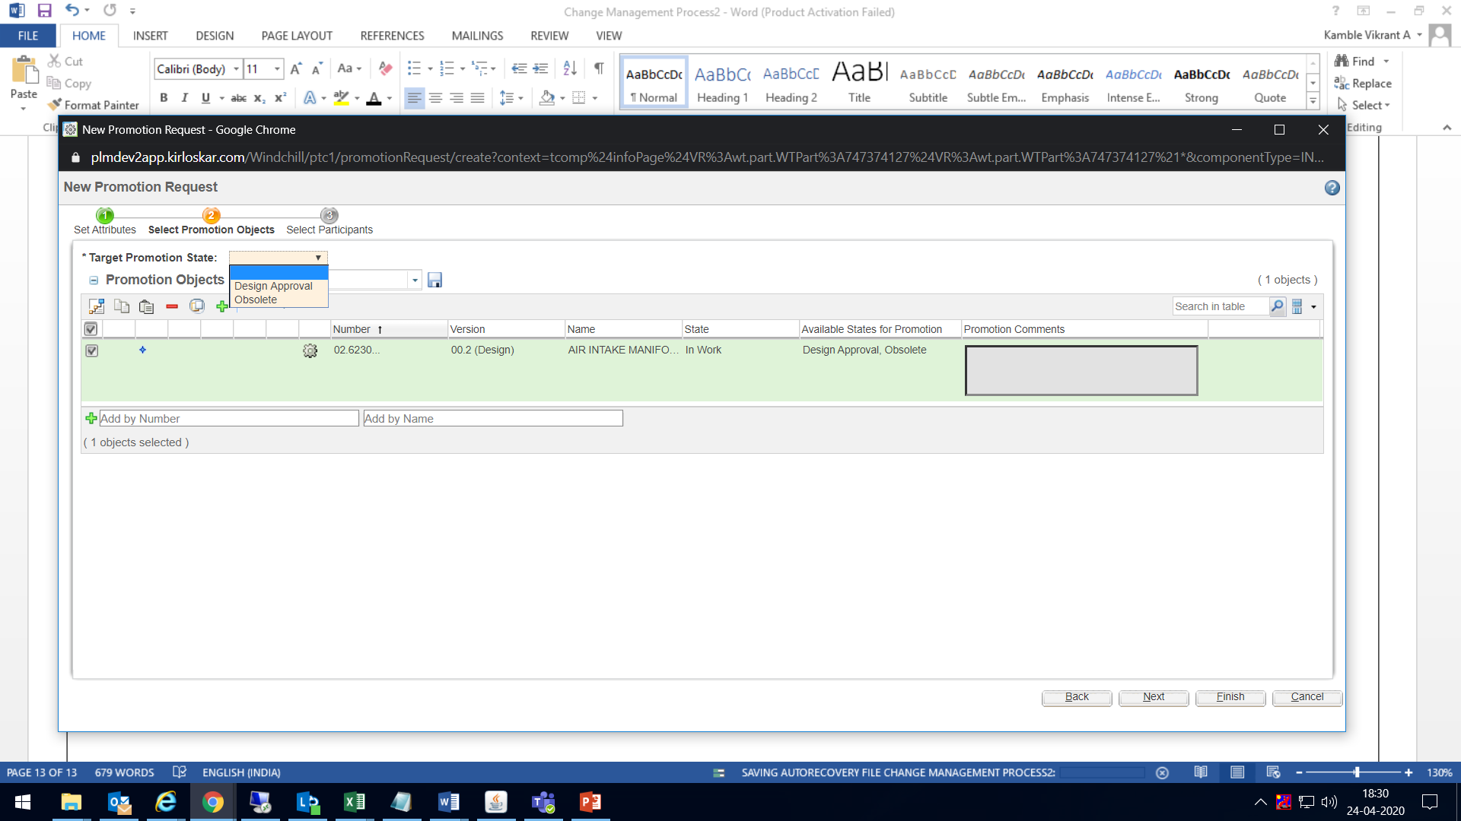

- A promotion request is created with a pop up available.

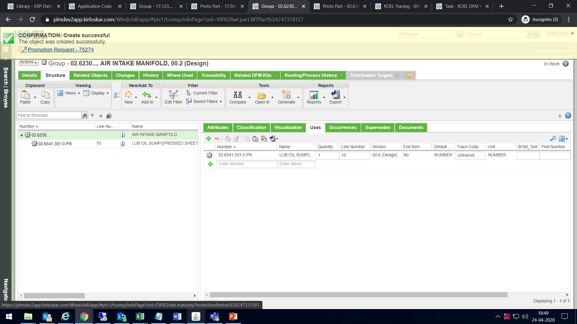

- Open this promotion request and complete the Review Promotion Object task.
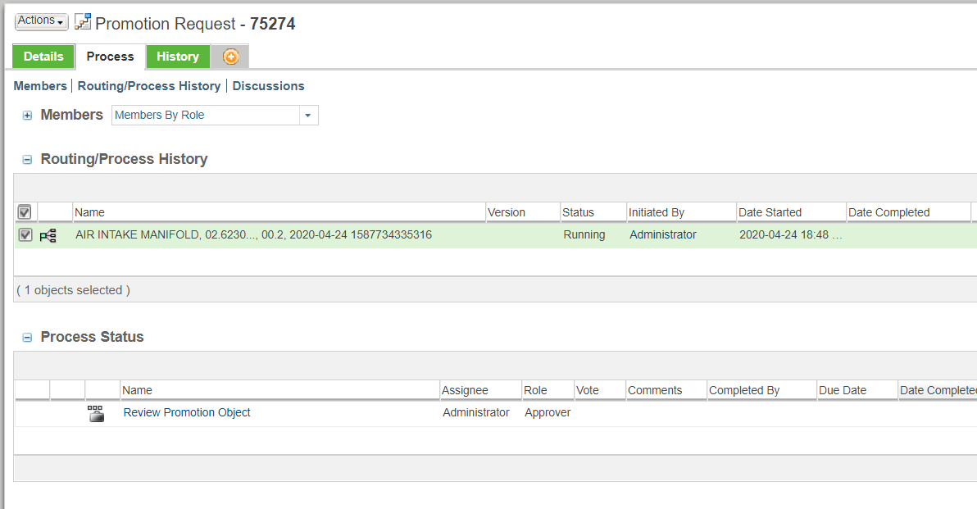

- After the task is completed the state changes to Approved.

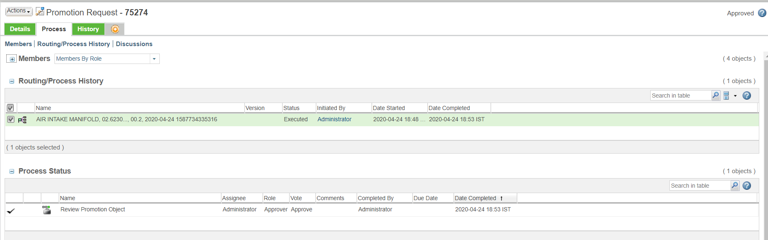

- Group is in now in Design Approval state with “Select Manufacturing Location” as available task .

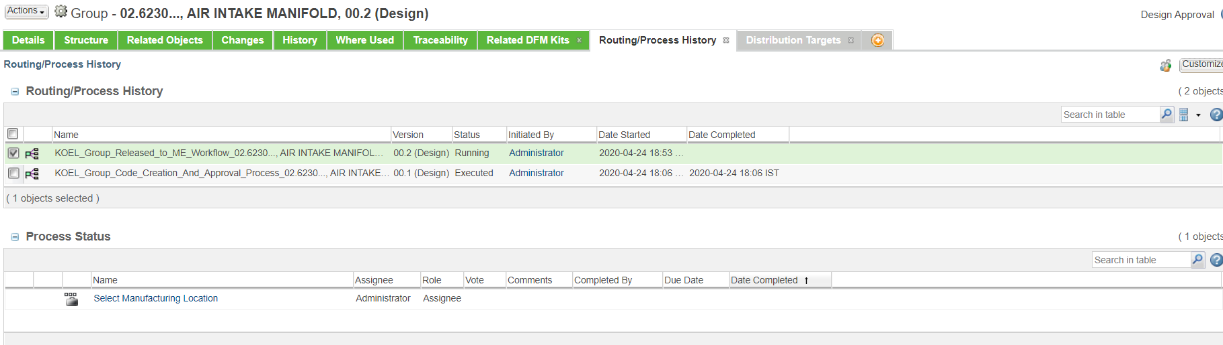

- Select the manufacturing locationfrom drop down and complete the task.

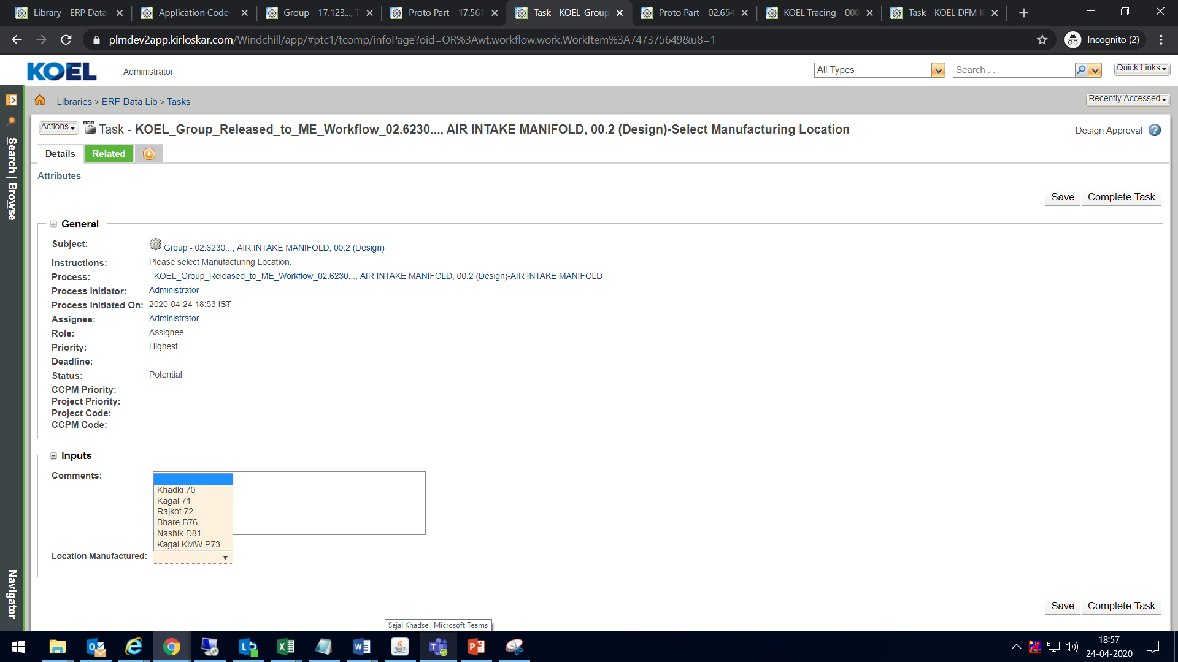

- The state of group is now changed to Release to ME.

